***PRACTICAL–7***

**Aim:** **Design Class and Object Diagram for software domain problem.**

* **Basic Overview:**
* A class diagram is a type of UML (Unified Modeling Language) diagram that visually represents the structure of a system by showing its classes, attributes, methods, and relationships between objects.

* **Key Elements:**

1. **Classes:** 
   * + Represented as rectangles with three sections:
     + Class Name
     + Attributes
     + Methods (Functions/Operations**)**
     + The Access of each attribute and method is symbolized by:
       - 1. **+ (Public Member)**: The attribute or method is accessible from anywhere.
         2. **- (Private Member)**: The attribute or method is only accessible within the same class.
         3. **# (Protected Member)**: The attribute or method is accessible within the class and its subclasses.

1. **Relationships** 
   * The connections between classes
   * They are:
     1. **Association (──────────────)**
     2. **Inheritance (────────**▷**)**
     3. **Aggregation (────────**◇**)**
     4. **Composition (────────**◆**)**

* **Conclusion:**

* UML class diagrams are a powerful tool for visually representing the structure and relationships within a system. By understanding and correctly applying these relationships, software architects and developers can design scalable, maintainable, and well-structured systems**.** Properly defining these connections ensures a clear representation of dependencies and interactions, improving both development and communication among stakeholders.

* **For Online Job Portal System:**

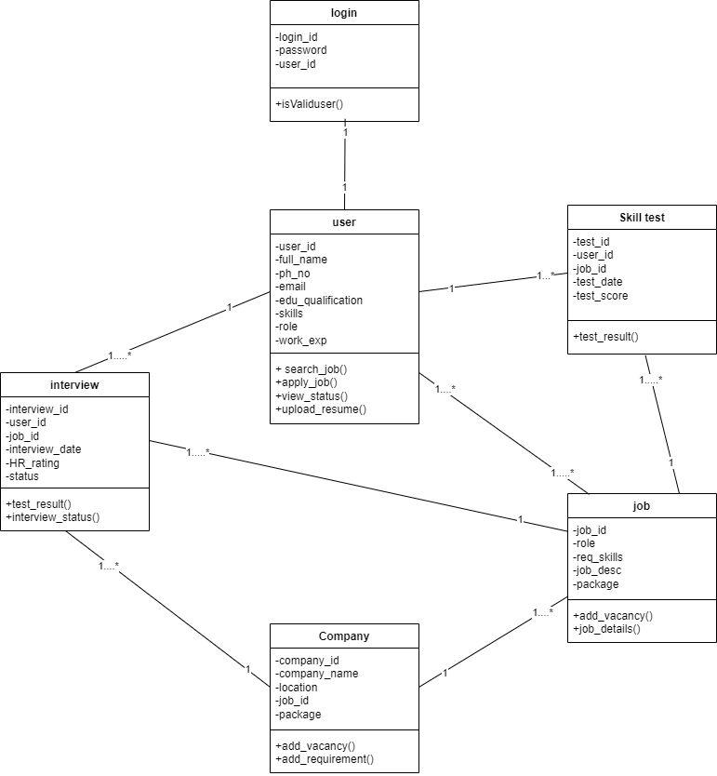

* **Key Entities and Their Relationships:**

1. Login
   * The user must first log in to access the job portal system.
   * This ensures authentication and user validation before proceeding with any job-related activities.
2. User
   * The main entity representing job seekers.
   * Has a one-to-many (1..*) relationship with Skill Test, Jobs, and Interviews.
3. Skill Test
   * A user can take multiple skill tests to enhance their chances of getting hired.
   * The relationship between User and Skill Test is one-to-many (1..*), meaning a user can take multiple tests, but each test belongs to one user.
4. Job
   * A user can apply for multiple jobs, and a job can have multiple applicants.
   * There is a one-to-many (1..*) relationship between User and Job.
   * Each job is associated with a Company, meaning a Company can have multiple Job listings (one-to-many (1..*)).
5. Company
   * Represents employers posting jobs on the portal.
   * Has a one-to-many (1..*) relationship with Jobs, meaning a company can post multiple jobs.
6. Interview
   * Users who apply for jobs and get shortlisted go through an interview process.
   * There is a one-to-many (1..*) relationship between User and Interview, meaning a user can attend multiple interviews.
   * A Job also has a one-to-many (1..*) relationship with Interview, meaning a single job opening may lead to multiple interviews.